**CLASSIFICATION OF ARRHYTHMIA BY USING DEEP LEARNING WITH**

**2-D ECG SPECTRAL IMAGE REPRESENTATION**

# A PRIEE REPORT

***Submitted by***

|  |  |
| --- | --- |
| **HARISH K P** | **(111720102040)** |
| **JAYANTH J J** | **(111720102047)** |
| **KARTIKEY MISHRA** | **(111720102055)** |
| **CIBIYARASU S** | **(111720102030)** |
| **BALAJI V** | **(111720102016)** |

***in partial fulfillment for the award of the degree of***

# BACHELOR OF ENGINEERING

**IN COMPUTER SCIENCE AND ENGINEERING**

# R.M.K. ENGINEERING COLLEGE

(An Autonomous Institution)

## R.S.M. Nagar, Kavaraipettai-601 206



**November 2023**

# R.M.K. ENGINEERING COLLEGE

## (An Autonomous Institution)

**R.S.M. Nagar, Kavaraipettai-601 206**

## BONAFIDE CERTIFICATE

Certified that this project report “**Classification of Arrhythmia by Using Deep Learning with 2-D ECG Spectral Image Representation**” is the bonafide work of **HARISH K P (111720102040), JAYANTH J J (111720102047), KARTIKEY MISHRA (111720102055), CIBIYARASU S (111720102030), BALAJI V (111720102016)** who carried out the 20CS513 Mini Project and Design Thinking work under my supervision.

**SIGNATURE SIGNATURE**

**Dr. Jeno Jasmine Dr. T. Sethukarasi, M.E., M.S. Ph.D.,**

**Supervisor Professor and Head**

Assistant professor Department of Computer Science and

Department of Computer Science and Engineering

Engineering R.M.K. Engineering College

R.M.K. Engineering College R.S.M. Nagar, Kavaraipettai,

R.S.M. Nagar, Kavaraipettai, Tiruvallur District– 601206. Tiruvallur District–601206.

Submitted for the Project Viva–Voce held on ……………………… at **R.M.K. Engineering**

**College**, Kavaraipettai, Tiruvallur District– 601206.

**INTERNAL EXAMINER**

## ACKNOWLEDGEMENT

We earnestly portray our sincere gratitude and regard to our beloved **Chairman Shri. R. S.**

**Munirathinam, our Vice Chairman, Shri. R. M. Kishore** and **our Director, Shri. R.**

**Jyothi Naidu,** for the interest and affection shown towards us throughout the course.

We convey our sincere thanks to our **Principal**, **Dr. K. A. Mohamed Junaid,** for being the source of inspiration in this college.

We reveal our sincere thanks to our **Professor and Head of the Department, Computer Science and Engineering, Dr. T. Sethukarasi,** for her commendable support and encouragement for the completion of our project.

We would like to express our sincere gratitude for project guide **Dr. Jeno Jasmine**, assistant professor for their valuable suggestions towards the successful completion for this project in a global manner.

We take this opportunity to extend our thanks to all faculty members of Department of Computer Science and Engineering, parents and friends for all that they meant to us during the crucial times of the completion of our project.

**TABLE OF CONTENTS**

|  |  |  |
| --- | --- | --- |
| **CHAPTER** | **TITLE** | **PAGE NO** |
|  | **ABSTRACT** | 5 |
|  | **LIST OF FIGURES** | 6 |
| **1** | **INTRODUCTION** | 7 |
|  | 1.1 Problem Statement |  |
|  | 1.2 Project Scope and Objectives |  |
|  | 1.3 Literature Survey |  |
|  | 1.4 Hardware Requirements |  |
|  | 1.5 Software Requirements |  |
| **2** | **SYSTEM ANALYSIS** | 10 |
|  | 2.1 Existing System |  |
|  | 2.1.1 Disadvantages of Existing System |  |
|  | 2.2 Proposed System |  |
|  | 2.2.1 Advantages of Proposed System |  |
| **3** | **SYSTEM DESIGN** |  |
|  | 3.1 System Architecture |  |
|  | 3.2 Use Case Diagram |  |
|  | 3.3 Class Diagram |  |
|  | 3.4 Data Flow Diagram |  |
|  | 3.5 Activity Diagram |  |
| **4** | **SYSTEM IMPLEMENTATION** |  |
|  | 4.1 Modules |  |
|  | 4.2 Module Description |  |
|  | 4.3 Algorithms |  |
| **5** | **CONCLUSION** |  |
|  | **REFERENCES (List out min 10)** |  |
|  | **SCREENSHOTS** |  |

# ABSTRACT

Traditional ECG analysis primarily relies on manually engineered features, potentially missing subtle but crucial patterns. In contrast, our approach transforms ECG signals into 2-D spectral images, encapsulating both temporal and spectral information. Deep learning models, including convolutional neural networks (CNNs) and recurrent neural networks (RNNs), process these images. Trained on diverse arrhythmia data, these models autonomously learn discriminative features, outperforming traditional methods with higher accuracy, sensitivity, and specificity.

In this study, we introduce an innovative approach to improve the accuracy and interpretability of arrhythmia classification. Cardiac arrhythmias are a significant health concern, demanding timely and precise diagnosis for effective patient care. Our method leverages deep learning techniques alongside a unique 2-D ECG spectral image representation.

Moreover, the use of 2-D ECG spectral images enhances interpretability, allowing clinicians to visualize the learned features and build trust in automated arrhythmia detection systems. This approach shows promise in revolutionizing arrhythmia diagnosis, potentially leading to improved patient care and outcomes. Further research and development in this direction hold significant potential for the healthcare industry.

**LIST OF FIGURES**

|  |  |  |
| --- | --- | --- |
| **FIG.NO** | **FIGURE NAME** | **PAGE NUMBER** |
| 1. | Use case diagram | 14 |
| 2. | Activity Diagram | 15 |
| 3. | Data Flow Diagram | 16 |
| 4. | System architecture | 17 |
| 5. | Loss vs Epochs | 26 |
| 6. | Accuracy vs Epochs | 27 |
| 7. | Val Accuracy vs Epochs | 28 |

## CHAPTER 1

### INTRODUCTION

**1.1 Problem Statement**

The main problem is that to identify a specific medical condition known as Arrhythmia, also known as dysrhythmia, which is characterized by an abnormal heart rhythm or heartbeat. Normally heartbeat will be detected in a regular pattern but in arrhythmia this pattern has be disturbed which leads to irregular heartbeats such as too fast (tachycardia), too slow (bradycardia), or irregular in their rhythm. Thus, these irregular heartbeats lead to various problems like Reduced Cardiac Output, Blood Clots, Heart Failure, Angina (Chest Pain), Sudden Cardiac attack. Thus, our project is to identify understand these Arrhythmia pattern and take precaution measures for it.

**1.2 Project Scope and Objective:**

**1.2.1 Scope of the Project:**

The project scope is to identify the Arrhythmia condition of a patient by analyzing the medical reports which have in image format. Additionally, a brief report of the arrhythmia condition has been shown in a visual format which helps us to understand it in a better.

**1.2.2 Objective of the Project:**

The basic objective of our project is to develop an automated system which can able to detect the different types of Arrhythmias in a more accurate and effective manner from the electrocardiogram (ECG) data provided. Furthermore, this approaches the deep learning techniques and transforms the ECG signals into 2-D spectral images to understand the classification process.

**1.3 Literature Survey**

In these papers, various approaches are presented for the classification of cardiac arrhythmias using electrocardiogram (ECG) signals. They leverage advanced techniques such as deep learning, machine learning, and feature extraction to improve the accuracy of arrhythmia detection. Different datasets, including the MIT-BIH database, are utilized for experimentation. The proposed methods achieve impressive accuracy rates, often exceeding 90%, demonstrating their potential in assisting cardiologists with the early diagnosis and classification of heart conditions. These studies highlight the growing role of artificial intelligence and deep learning in enhancing the capabilities of ECG analysis, ultimately contributing to more effective and accurate cardiac disease detection and diagnosis. **[1]**

The paragraph discusses the increasing importance of artificial intelligence (AI) in the field of medical treatment, particularly in the context of electrocardiogram (ECG) analysis for heart diseases. Their experimental results indicate a high-performance level, achieving a score of 0.863 (micro-F1-score) in classifying 55 types of arrhythmias, surpassing the capabilities of ordinary human experts. However, the study acknowledges limitations, such as the need for more extensive datasets and clinical verification of the results, and suggests future improvements, potentially incorporating advanced network models like EfficientNet. A study aimed at classifying cardiac arrhythmias using electrocardiogram (ECG) signals through the application of machine learning and feature extraction techniques. The feature importance analysis revealed the significance of the dissimilarity feature of the GLCM, highlighting the effectiveness of the proposed feature extraction method in ECG signal classification. **[2]**

This paper presents an intelligent approach for classifying cardiac arrhythmias using deep learning, specifically Convolutional Neural Networks (CNNs). The aim is to effectively screen and distinguish patients with various cardiovascular arrhythmias, such as Atrial Fibrillation, Ventricular Tachycardia, and Ventricular Fibrillation, using ECG signals. The CNN is trained on ECG data from the MIT-BIH Database, automatically learning features from the time domain signals. The study compares different activation functions and finds that the Exponential Linear Unit (ELU) activation function yields the best results, achieving an impressive accuracy of 93.6%. This approach has the potential to aid cardiologists in efficiently diagnosing cardiac illnesses based on ECG data. **[3]**

The critical importance of maintaining a healthy heart and the role of the Electrocardiogram (ECG) in diagnosing heart disorders, specifically arrhythmia. Arrhythmia, characterized by irregular heart rhythms, is classified into Tachycardia and Bradycardia. The paper discusses various techniques, including Deep CNNs,

LSTM, SVM, NN classifier, Wavelet, and TQWT, employed over the past decade to detect arrhythmia using

ECG datasets. These techniques involve data preprocessing, feature extraction, and classification processes, showing improved performance in ECG signal classification for arrhythmia detection. The research emphasizes the significance of automatic arrhythmia detection, as it can aid cardiologists in making rapid, life-saving decisions. However, it also acknowledges research limitations and challenges in the detection of abnormal heartbeats, underscoring the need for further work in this vital area of healthcare. **[4]**

This paper highlights the significance of ECG in diagnosing cardiac arrhythmia and presents an efficient technique utilizing a general spared neural network (GSNN) for accurate classification. The study employs the MIT-BIH arrhythmia dataset with 16 different subclasses and employs an adaptive threshold technique to reduce noise and extract QRS beats from ECG records. These extracted features are then processed through a backpropagation neural network, achieving an impressive 98% accuracy in arrhythmia classification. The GSNN demonstrates its efficiency in classifying various arrhythmia conditions, offering medical practitioners a valuable tool for interpreting ECG signals and diagnosing heart problems. Future work aims to further enhance performance by comparing this classification algorithm with other deep learning classifiers. In modern medical devices, signal processing (SP) algorithms are closely integrated with decision-making algorithms, and their performance significantly impacts each other. This is particularly relevant in the context of Implantable Cardioverter Defibrillators (ICDs), where a Peak Detection (PD) algorithm process input electrograms to identify heartbeats. **[5]**

This paper highlights the significance of ECG in diagnosing cardiac arrhythmia and presents an efficient technique utilizing a general sparse neural network (GSNN) for accurate classification. The study employs the MIT-BIH arrhythmia dataset with 16 different subclasses and employs an adaptive threshold technique to reduce noise and extract QRS beats from ECG records. These extracted features are then processed through a backpropagation neural network, achieving an impressive 98% accuracy in arrhythmia classification. The GSNN demonstrates its efficiency in classifying various arrhythmia conditions, offering medical practitioners a valuable tool for interpreting ECG signals and diagnosing heart problems. Future work aims to further enhance performance by comparing this classification algorithm with other deep learning classifiers. **[6]**

This paper addresses the critical issue of safety in implantable medical devices, particularly implantable cardioverter defibrillators (ICDs). These devices are crucial for distinguishing between fatal and non-fatal arrhythmias in cardiac signals, and their algorithms must adhere to strict constraints, including memory usage and runtime efficiency. To enhance the reliability and performance assessment of arrhythmia detection algorithms, the authors introduce the use of Quantitative Regular Expressions (QREs), a formal language for expressing complex numerical queries over data streams. They demonstrate that QREs are well-suited for specifying peak detection algorithms and various discriminators within arrhythmia detection devices. This formalization enables rigorous testing and analysis, reducing regulatory challenges for developers modifying these algorithms. The paper showcases the effectiveness of their approach by applying QRE-based monitors to real patient data, yielding results comparable to those reported in the medical literature. **[7]**

This article explores the application of deep learning techniques for heartbeat classification using publicly available ECG datasets, including the MIT-BIH arrhythmia database and the PTB Diagnostic ECG Database. Various models, such as CNN, CNN + LSTM, and CNN + LSTM + Attention, were employed for classification. Training was performed on 80% of the data, with the remaining 20% used for testing. The results demonstrate remarkable accuracy, with a 99.12% accuracy rate for the CNN model, 99.3% for CNN + LSTM, and 99.29% for CNN + LSTM + Attention. While there is a possibility of overfitting due to the inclusion of ten residual blocks, the model's high accuracy highlights its potential for accurate predictions.

Future research could focus on applying these techniques in cloud and mobile systems and developing integrated low-power wearable technologies. **[8]**

We propose a waveform-based signal processing method for electrocardiogram. More importantly, we demonstrate how WBSP can be applied to devise machine learning-based and deep learning-based arrhythmia classifiers. In arrhythmia classification tasks, we achieved one of the state-of-the art performances with an accuracy of 98.8%, sensitivity of 96.3% in class V, and sensitivity of 98.6% in class Q. In addition, we found the key waveform parameters that contribute to arrhythmia classification with the proposed WBSP method. We intend to explore WBSP on different bio signals in the future. **[9]**

**1.4 Hardware Requirements**

The hardware requirements would be any kind of internet connection like WIFI, modem data etc, to allow the browser interfaces to connect to the website. The website can be accessed through any devices like mobile, computer, laptop, tablet, etc. Any popular OS that will allow the use of a browser to view and access web pages. In order to make the user comfortable, all the main details have been detailed in the Home page of the website itself.

**1.5 Software Requirements**

Some of the software interfaces which you can use to access our website are

* Opera for Windows 10 PC - Version 105.0.4963.0
* Google chrome for Windows - Version 119.0. 6045.105
* Google chrome for macOS - Version 119.0. 6045.105
* Google chrome for Android - Version 119.0. 6045.105
* Mozilla Firefox for Windows - Version 119.0
* Microsoft Edge for Windows 10 - Version 118.0.2088.76
* Microsoft Edge for macOS - Version 118.0.2088.76
* Microsoft Edge for iOS - Version 118.0.2088.76

**CHAPTER 2**

### SYSTEM ANALYSIS

**2.1 Existing System**

The existing systems focus on achieving the same objective of creating an easy yet effective classification model. The exiting applications provide a proper classification of the types of arrythmia in result helps the patient to under correct diagnosis.

**2.1.1 Disadvantages of Existing System**

However, the existing systems are developed in such drawbacks:

**Data Quality and Variability:** ECG data can be noisy, and the quality of the data may vary between different patients and recording equipment. Variability in the ECG signals can make it challenging to train deep learning models effectively.

**Large and Annotated Datasets:** Deep learning models, especially convolutional neural networks (CNNs), require large, well-annotated datasets for training. Collecting and labeling a substantial amount of ECG data for various arrhythmia types can be time-consuming and expensive.

**Overfitting:** Deep learning models are prone to overfitting, which occurs when a model performs well on the training data but poorly on unseen data. Addressing overfitting issues is essential to ensure the model's generalization to new ECG data.

**2.2 PROPOSED SYSTEM**

To overcome these challenges and drawbacks, researchers and developers working on arrhythmia classification systems using deep learning with 2-D ECG spectral image representation should focus on data collection and curation, model architecture and optimization, interpretability, regulatory compliance, and the integration of AI into the clinical workflow. Collaboration between machine learning experts and healthcare professionals is essential to create reliable and effective systems for arrhythmia diagnosis and classification.

**2.2.1 Advantages of Proposed System**

The proposed system provides well defined Convolutional Neural Networks (CNNs) to classify arrhythmias based on 2-D ECG spectral image representations. CNNs are a type of deep learning model particularly well-suited for image-related tasks, and ECG spectral image representations can capture important features of ECG signals that are useful for arrhythmia classification. Here are some potential advantages of such a system:

**Improved accuracy:**

Deep learning models, such as CNNs, have shown excellent performance in various image classification tasks. They can learn complex patterns and relationships within ECG spectral images, potentially leading to higher accuracy in arrhythmia classification.

**Automation:**

Once trained, the system can automate the arrhythmia classification process, reducing the need for manual interpretation of ECG signals by medical professionals. This can speed up diagnosis and reduce the risk of human error.

**Scalability:**

Deep learning models can be scaled to handle a large volume of ECG data, making it suitable for processing and analyzing a vast amount of patient records efficiently.

**Faster diagnosis:**

With automation and potentially faster processing, the system can aid in quicker diagnosis, which can be crucial in emergency situations.

**CHAPTER 3**

### SYSTEM ANALYSIS

**3.1 SYSTEM ARCHITECTURE**

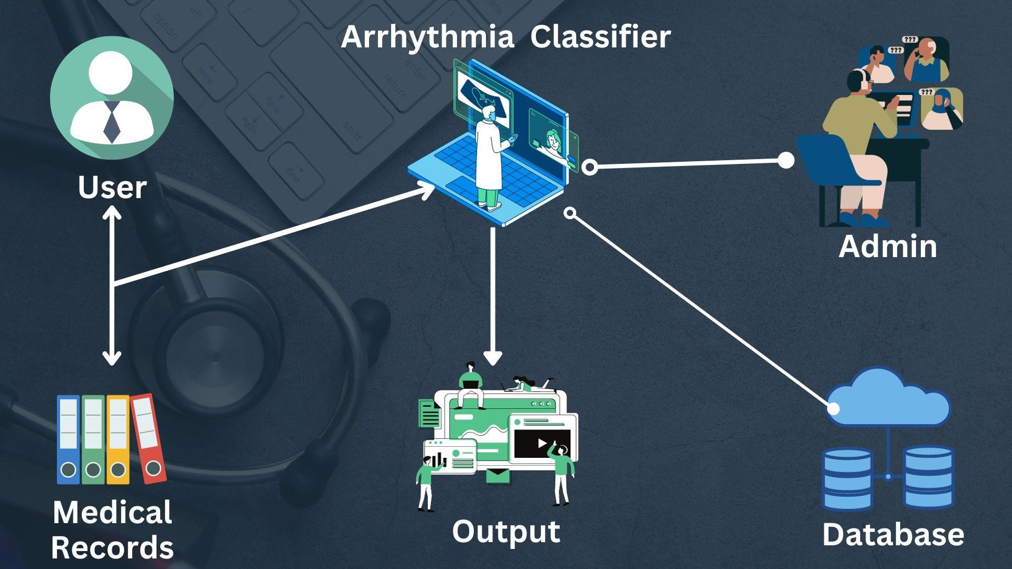

**Fig 3.4 SYSTEM ARCHITECTURE**

**3.3 USECASE DIAGRAM** 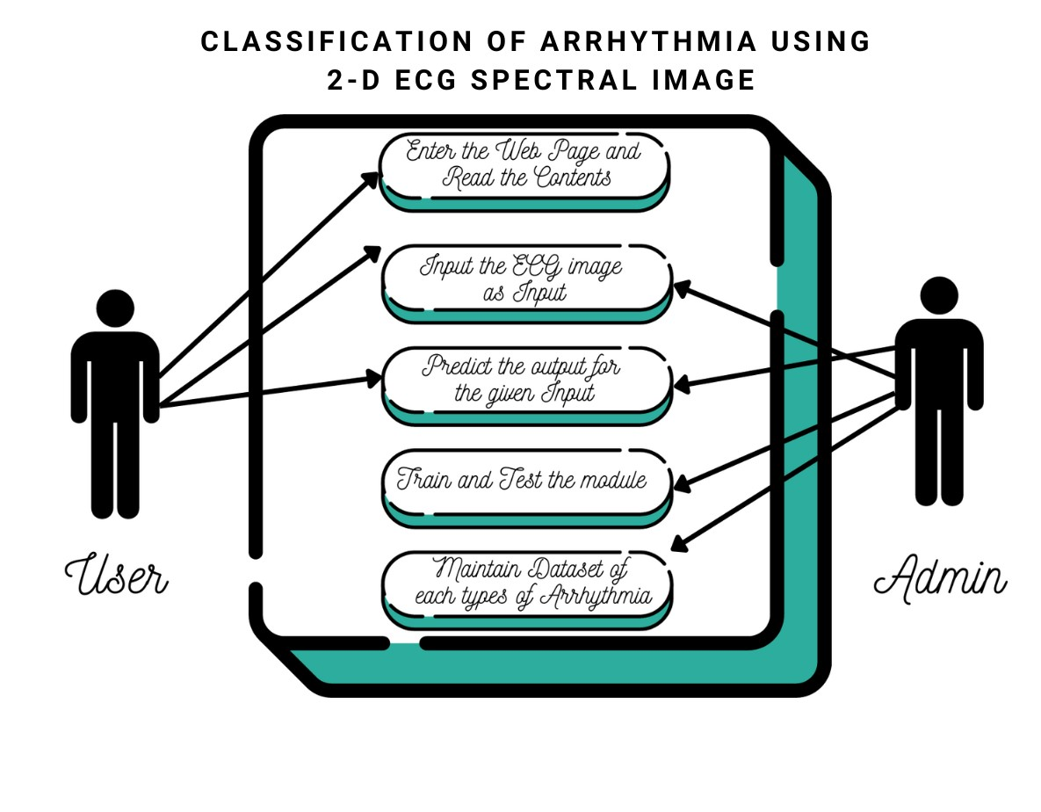

#### Fig 3.1 USECASE DIAGRAM

**3.4** **ACTIVITY DIAGRAM**

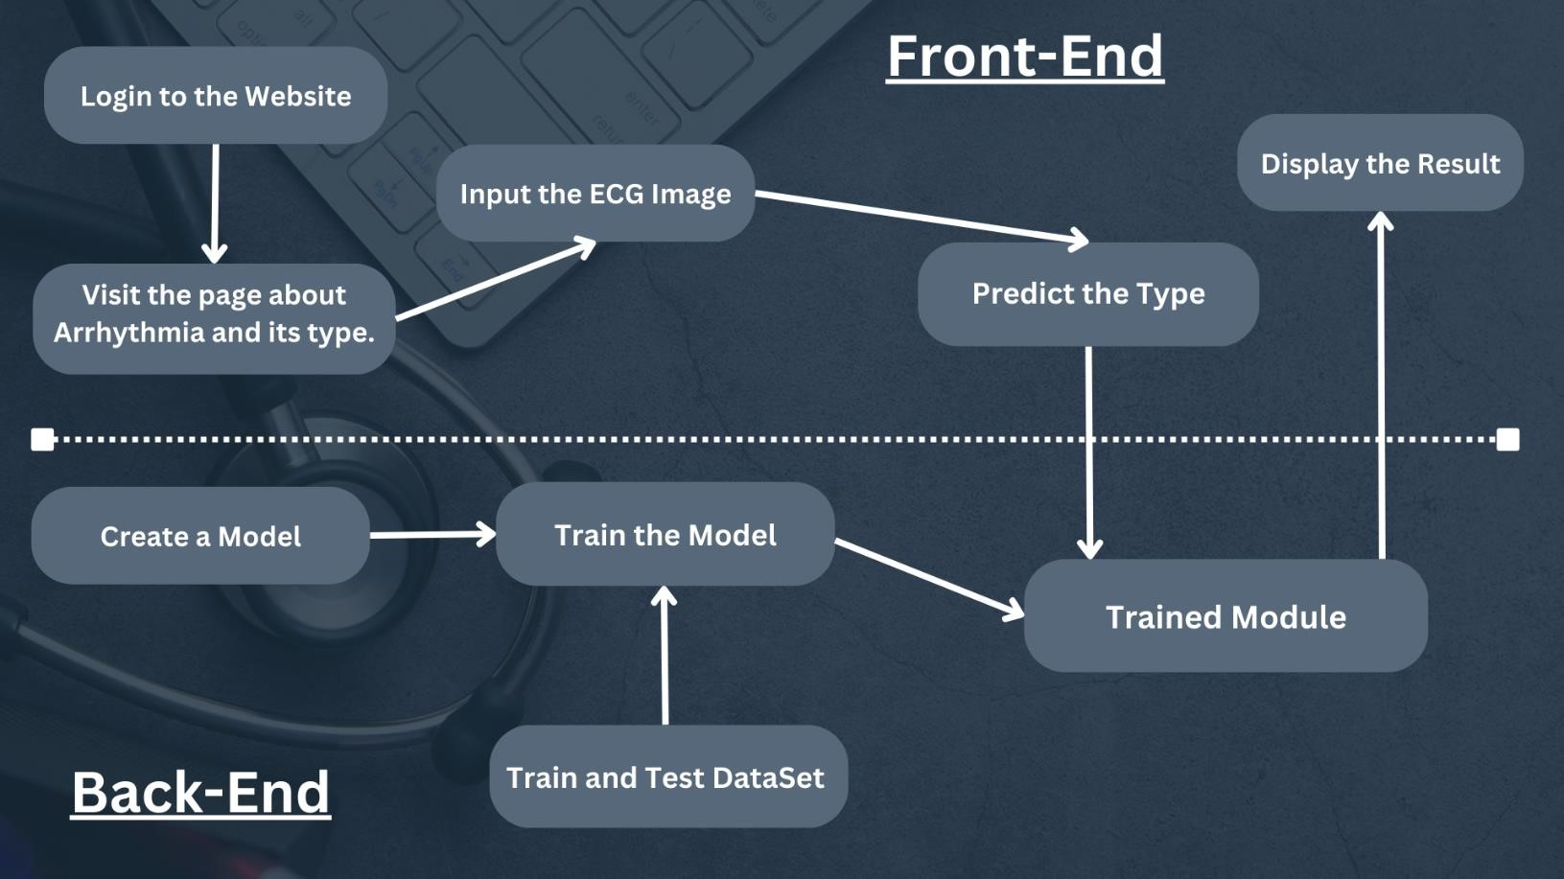

### Fig 3.2 Activity Diagram

**3.5** **Data Flow Diagram**

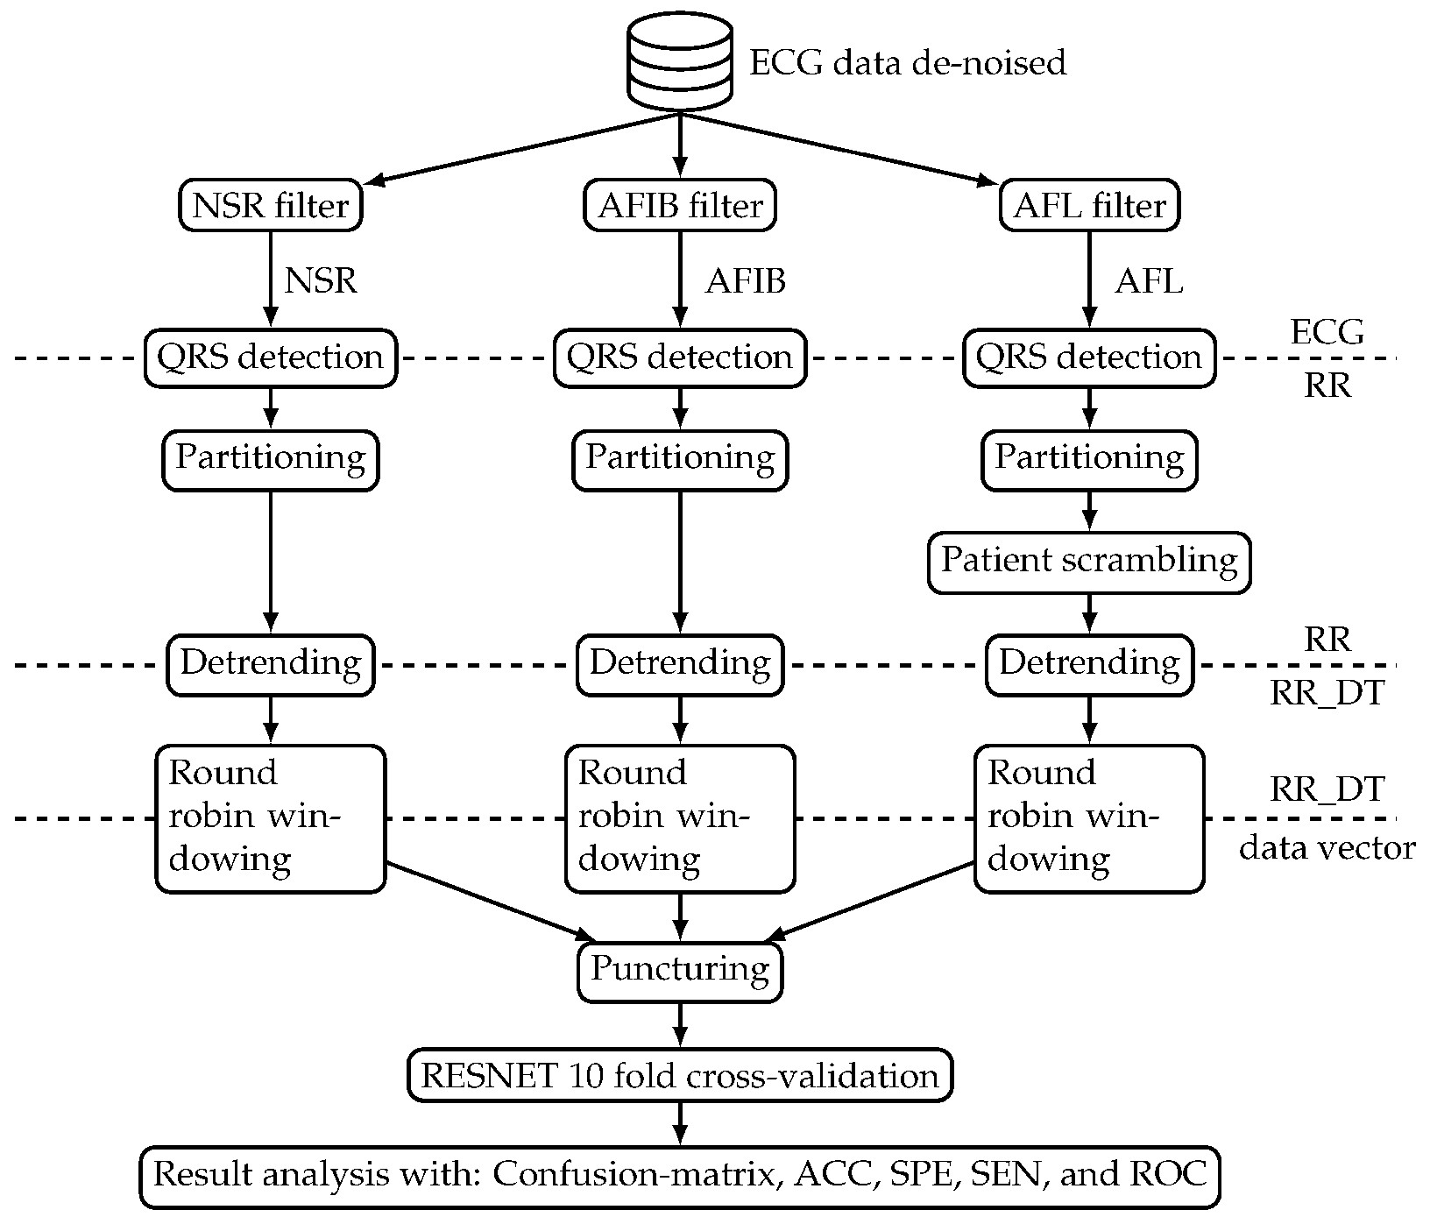

### Fig 3.3 Data Flow Diagram

**CHAPTER 4**

## SYSTEM IMPLEMENTAION

**4.1 LIST OF MODULES**

1. Home Page
2. Arrhythmia Classification Page
3. Train Module
4. Prediction page
5. Output Display page

**4.2 MODULE DESCRIPTION**

* + 1. **Home Page:**

In this module a web page contains login details which welcome tour project and also contains the navigation bar which helps to move to other pages.

* + 1. **Arrhythmia Classification Page:**

In this module it gives description about every arrhythmia type depending on the severity of the disease and possible health risks

* + 1. **Train Module:**

In this module we will train a model by import real datasets of the ECG reports of the arrythmia patients and make prediction out of it.

* + 1. **Prediction page:**

In this module we will enter the ECG report of the patient dataset in the web page to find out which type of arrythmia is it.

* + 1. **Output Display page:**

In this module it displays the output of the ECG report and also gives result depending on the data analysis of the ECG report of the patient.

**CHAPTER 5**

### FUTURE ENHANCEMENTS

In the future of arrhythmia classification using AI, there is a pressing need to address key areas for advancement. These include acquiring diverse and comprehensive datasets to enhance model accuracy, conducting clinical validation and integration to ensure realworld effectiveness, prioritizing privacy and security in ECG data analysis, and improving model interpretability for transparency and trust. Exploring transfer learning, wearable technology for continuous monitoring, and computational efficiency optimization will be crucial. Interdisciplinary collaborations and strict adherence to regulatory standards will bridge the gap between cutting-edge research and clinical practice, promising a future where AI-driven arrhythmia classification transforms healthcare while safeguarding patient privacy and data security.

To enhance the classification of arrhythmia using deep learning with 2-D ECG spectral image representation, several avenues of improvement can be explored. These include acquiring larger and more diverse datasets, implementing data augmentation techniques, and considering transfer learning for efficiency. Hybrid models combining spectral images with other ECG data representations can capture a broader range of arrhythmia patterns. The development of interpretable models, realtime monitoring systems, and clinical validation in collaboration with healthcare professionals is essential. Further enhancements may involve online learning, addressing privacy and security concerns, and fostering human-AI collaboration in healthcare settings. Model explainability, hardware optimization, and the incorporation of multi-modal patient data can increase the model's utility and trustworthiness. Continuous monitoring, feedback mechanisms, and mobile applications for remote patient monitoring are also promising directions. Collaboration with cardiologists, alignment with clinical guidelines, and regulatory approvals for clinical use should be integral to the project's future development, ensuring its safety and efficacy while respecting ethical and legal considerations.

**CHAPTER 6**

### CONCLUSION

In summary, collectively highlight the increasing importance of artificial intelligence, with a particular focus on deep learning and machine learning, within the realm of cardiac healthcare and the classification of cardiac arrhythmias using electrocardiogram (ECG) signals. These studies consistently demonstrate remarkable levels of accuracy, often surpassing the 90% threshold, in classifying a wide range of arrhythmia types, exceeding the diagnostic capabilities of human experts.

These breakthroughs hold promising implications for assisting cardiologists in the early diagnosis and precise classification of heart conditions, ultimately contributing to more effective and accurate detection and diagnosis of cardiac diseases. However, it is crucial to acknowledge the research's limitations, as outlined in these papers. These limitations include the imperative need for larger and more diverse datasets, the critical requirement for clinical validation of the results, and the ongoing pursuit of overcoming challenges and enhancing these AI-driven methodologies.

Collectively, these studies underscore the transformative potential of artificial intelligence in augmenting ECG analysis, potentially revolutionizing the field of cardiac healthcare. This progress provides valuable tools for interpreting ECG signals and diagnosing cardiac issues, with future research aiming to build upon these promising results. This includes the exploration of advanced network models and the consideration of applications in wearable technologies, cloud systems, and mobile healthcare solutions.

### REFERENCES

1. JUNXIAN CAl , WEIWEI SUN , JIANFENG GUAN , (Member, IEEE), AND ILSUN YOU, (Senior Member, IEEE), Multi-ECG Net for ECG Arrythmia Multi-Label

Classification, date of Published: June 10, 2020.

1. Lee, H.; Yoon, T.; Yeo, C.; Oh, H.; Ji, Y.; Sim, S.; Kang, D. Cardiac Arrhythmia Classification Based on One-Dimensional Morphological Features, date of Published: 12 October 2021.

1. Sanjay Tanaji Sanamdikar, Satish Tukaram Hamde, Vinayak Ganpat Asutkar, Analysis and classifcation of cardiac arrhythmia based on general sparsed neural network of ECG signals, date of Published:18 June 2020

1. Wusat Ullah, Imran Siddique , Rana Muhammad Zulqarnain , Mohammad Mahtab Alam ,

Irfan Ahmad, and Usman Ahmad Raza, Classification of Arrhythmia in Heartbeat Detection Using Deep Learning, date of Published:19 October 2021

1. Po-Ya Hsu and Chung-Kuan Cheng, Arrhythmia Classification using Deep Learning and Machine Learning with Features Extracted from Waveform-based Signal Processing, date of Published: August 31,2020.

1. Houssam Abbas, Alena Rodionova, Konstantinos Mamouras, Ezio Bartocc, Scott A. Smolka, Quantitative Regular Expressions for Arrhythmia Detection, date of Published: April 19, 2018.

1. Rajkumar. A, Ganesan. M, Lavanya. R, Arrhythmia classification on ECG using Deep Learning, Arrhythmia classification on ECG using Deep Learning, date of Published: 2019 5th International Conference on Advanced Computing & Communication Systems (ICACCS)

1. Taminul Islam, Arindom Kundu, Tanzim Ahmed, Nazmul Islam Khan, Analysis of Arrhythmia Classification on ECG Dataset.

1. Elif IZCI, Mehmet Akif OZDEMIR, Murside DEGIRMENCI, and Aydin AKAN, Cardiac Arrhythmia Detection from 2D ECG Images by Using Deep Learning Technique, date of Published: 2019 IEEE

### SAMPLE CODING

*#import the nueral network libraries* **from** tensorflow.keras.models **import** Sequential **from** tensorflow.keras.layers **import** Dense

In [2]:

*#import the cnn layers* **from** tensorflow.keras.layers **import** Convolution2D **from** tensorflow.keras.layers **import** MaxPooling2D **from** tensorflow.keras.layers **import** Flatten

#### Image preprocessing (or) data Augmentation

In [3]:

**from** tensorflow.keras.preprocessing.image **import** ImageDataGenerator

In [4]:

train_datagen**=**ImageDataGenerator(rescale**=**1.**/**255,shear_range**=**0.2,zoom_range**=**0.2,horizonta l_flip**=True**)

In [5]:

test_datagen**=**ImageDataGenerator(rescale**=**1.**/**255)

In [6]:

x_train

**=**train_datagen**.**flow_from_directory("C:/Users/haris/OneDrive/Desktop/classification-ofArrhythmia/Code/ECG-

Dataset/Dataset/train",target_size**=**(64,64),batch_size**=**32,class_mode**=**"categorical") Found 15341 images belonging to 6 classes.

In [7]:

x_test **=** test_datagen**.**flow_from_directory("C:/Users/haris/OneDrive/Desktop/classification-ofArrhythmia/Code/ECG-

Dataset/Dataset/test",target_size**=**(64,64),batch_size**=**32,class_mode**=**"categorical") Found 6825 images belonging to 6 classes.

In [8]:

x_train**.**class_indices

Out[8]:

{'Left Bundle Branch Block': 0,

'Normal': 1,

'Premature Atrial Contraction': 2,

'Premature Ventricular Contractions': 3,

'Right Bundle Branch Block': 4,

'Ventricular Fibrillation': 5}

In [9]:

*#initialize the model* model**=**Sequential()

In [10]:

*#convolutional model* model**.**add(Convolution2D(32,(3,3),input_shape**=**(64,64,3),activation**=**"relu"))

*#here 32 indiates no.of feature detectors and(3,3) is feature detector size*

In [11]:

*#pooling layer*

model**.**add(MaxPooling2D(pool_size**=**(2,2)))

In [12]:

*#flatten layer*

model**.**add(Flatten()) **hidden layers**

In [13]:

model**.**add(Dense(units**=**200,activation**=**"relu",kernel_initializer**=**"random_uniform"))

In [14]:

model**.**add(Dense(units**=**300,activation**=**"relu",kernel_initializer**=**"random_uniform"))

#### output layer

In [15]:

model**.**add(Dense(units**=**6,activation**=**"softmax",kernel_initializer**=**"random_uniform"))

#### compile model

In [16]:

model**.**compile(optimizer**=**"adam",loss**=**"categorical_crossentropy",metrics**=**["accuracy"])

#### train your model

In [17]:

tr**=**model**.**fit_generator(x_train,steps_per_epoch**=**480,epochs**=**25,validation_data**=**x_test,vali dation_steps**=**10)

*#steps_per_epoch =>total trainging images/batch size*

*#validation_steps=>total testing images/batch size*

C:\Users\haris\AppData\Local\Temp\ipykernel_14968\1370298909.py:1: UserWarning:

`Model.fit_generator` is deprecated and will be removed in a future version. Please use `Model.fit`, which supports generators.

tr=model.fit_generator(x_train,steps_per_epoch=480,epochs=25,validation_data=x_test,vali dation_steps=10)

Epoch 1/25

480/480 [==============================] - 87s 178ms/step - loss: 0.9403 - accuracy:

0.6650 - val_loss: 0.6864 - val_accuracy: 0.7625

Epoch 2/25

480/480 [==============================] - 87s 181ms/step - loss: 0.3387 - accuracy:

0.8931 - val_loss: 0.4659 - val_accuracy: 0.8594

Epoch 3/25

480/480 [==============================] - 85s 177ms/step - loss: 0.2356 - accuracy:

0.9259 - val_loss: 0.6305 - val_accuracy: 0.8156

Epoch 4/25

480/480 [==============================] - 90s 187ms/step - loss: 0.1702 - accuracy:

0.9482 - val_loss: 0.4248 - val_accuracy: 0.8719

Epoch 5/25

480/480 [==============================] - 85s 177ms/step - loss: 0.1397 - accuracy:

0.9572 - val_loss: 0.6356 - val_accuracy: 0.8344

Epoch 6/25

480/480 [==============================] - 86s 180ms/step - loss: 0.1056 - accuracy:

0.9679 - val_loss: 0.6817 - val_accuracy: 0.8687

Epoch 7/25

480/480 [==============================] - 313s 653ms/step - loss: 0.0842 - accuracy:

0.9741 - val_loss: 0.9815 - val_accuracy: 0.8406

Epoch 8/25

480/480 [==============================] - 265s 552ms/step - loss: 0.0714 - accuracy:

0.9760 - val_loss: 0.9907 - val_accuracy: 0.8438

Epoch 9/25

480/480 [==============================] - 95s 198ms/step - loss: 0.0735 - accuracy:

0.9776 - val_loss: 0.5919 - val_accuracy: 0.8594

Epoch 10/25

480/480 [==============================] - 92s 191ms/step - loss: 0.0597 - accuracy:

0.9808 - val_loss: 0.6131 - val_accuracy: 0.8562

Epoch 11/25

480/480 [==============================] - 92s 192ms/step - loss: 0.0564 - accuracy:

0.9825 - val_loss: 0.9602 - val_accuracy: 0.8344

Epoch 12/25

480/480 [==============================] - 95s 198ms/step - loss: 0.0526 - accuracy:

0.9836 - val_loss: 0.8597 - val_accuracy: 0.8625

Epoch 13/25

480/480 [==============================] - 90s 187ms/step - loss: 0.0477 - accuracy:

0.9847 - val_loss: 0.7316 - val_accuracy: 0.8438

Epoch 14/25

480/480 [==============================] - 101s 211ms/step - loss: 0.0438 - accuracy:

0.9858 - val_loss: 0.6611 - val_accuracy: 0.8844

Epoch 15/25

480/480 [==============================] - 92s 191ms/step - loss: 0.0361 - accuracy: 0.9891 - val_loss: 0.6194 - val_accuracy: 0.8813

In [18]:

tr**.**history

Out[18]:

{'loss': [0.940251886844635,

0.3386785089969635, 0.2356240302324295,

0.1701829731464386, 0.13972952961921692, 0.1056017056107521,

0.08421590179204941, 0.07142758369445801, 0.07348457723855972, 0.05966091528534889,

0.05643954128026962,

0.052617598325014114,

0.9915259480476379,

0.9887881875038147],

'val_loss': [0.6863967776298523,

0.46592217683792114, 0.6305422782897949,

0.42478522658348083,

0.6355851292610168,

0.6816785335540771,

1.247253179550171,

1.1456269025802612],

'val_accuracy': [0.762499988079071,

0.859375,

0.815625011920929,

0.871874988079071,

0.8343750238418579, 0.8687499761581421,

0.8656250238418579,

0.856249988079071,

0.8218749761581421]}

#### To save the best accuracy got in the epoch we will n use this callback and checkpoint

In [19]:

**from** tensorflow.keras.callbacks **import** ModelCheckpoint checkpoint **=**

ModelCheckpoint("best_model_{epoch:02d}.h5",monitor**=**"val_accuracy",save_best_only**=True**,m ode**=**"Max") lr **=** model**.**fit_generator(x_train,steps_per_epoch**=**480,callbacks**=**[checkpoint],validation_steps**=** 10)

WARNING:tensorflow:ModelCheckpoint mode Max is unknown, fallback to auto mode.

#### aving the model

In [20]:

*#for storing temporary* model**.**save('ECG.h5')

C:\Users\haris\anaconda3\Lib\site-packages\keras\src\engine\training.py:3079: UserWarning: You are saving your model as an HDF5 file via `model.save()`. This file format is considered legacy. We recommend using instead the native Keras format, e.g.

`model.save('my_model.keras')`. saving_api.save_model(

In [21]:

*#for storing permanent in drive*

model**.**save("C:/Users/haris/OneDrive/Desktop/classification-of-Arrhythmia/Code/ECGDataset/ECG.h5")

### SCREENSHOTS

In [22]:

losses**=**tr**.**history['loss'] accuracy**=**tr**.**history['accuracy']

epochs**=**list(range(1,26))

In [23]:

tr**.**history['loss'][5]

Out[23]:

0.1056017056107521

In [28]:

**import** matplotlib.pyplot **as** plt plt**.**plot(epochs,losses) plt**.**xlabel("epochs") plt**.**ylabel("loss") plt**.**show()

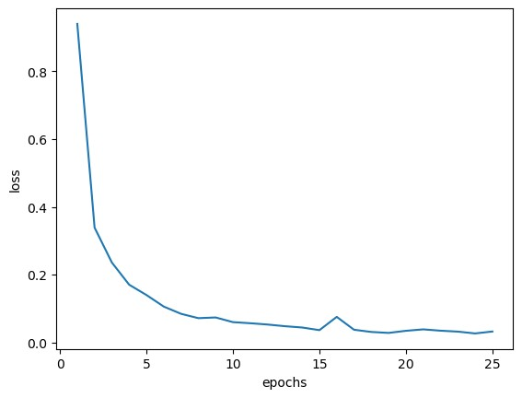

#### Fig2.1 Loss vs Epochs

In [29]:

plt**.**plot(epochs,accuracy) plt**.**xlabel("epochs") plt**.**ylabel("accuracy") plt**.**show()

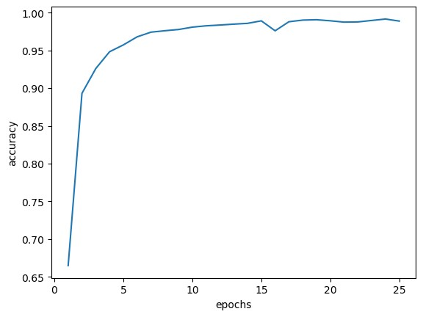

#### Fig2.2 Accuracy vs Epochs

In [26]:

losses**=**tr**.**history['loss'] accuracy**=**tr**.**history['accuracy'] val_accuarcy**=**tr**.**history['val_accuracy'] epochs**=**list(range(1,26))

In [27]:

plt**.**plot(epochs,val_accuarcy) plt**.**xlabel("epochs") plt**.**ylabel("accuracy") plt**.**show()

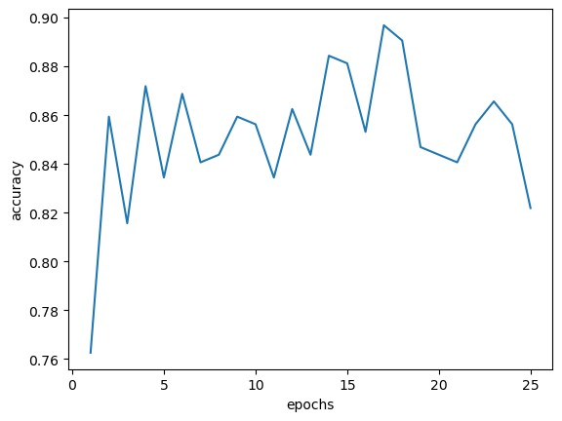

**Fig2.3 Val Accuracy vs Epochs**